IEP Student Calendar Fall 2024

 | August 2024
Sun | Mon | Tue | Wed | Thu | Fri | Sat
 |  |  |  | 1 | 2 | 3
4 | 5 | 6 | 7 | 8 | 9 | 10
11 | 12 | 13 |   14  IEP Placement  Testing  8:30 am – 12:00 pm  IEP Registration  1:00 pm – 4:00 pm  Intake Interviews    Get TigerCard | 15  IEP Orientation Part 1  9:00 am – 10:00 am  Email Training  10:00 am – 11:30 am  International Field Day  Kuhlman Court  11:00 am – 2:00 pm  (optional) | 16  Campus WalkingTour with  Recreation Center  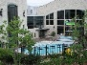  9:00 am – 11:30 am  Immigration Check-in  (F1,J1)  12:45 pm – 3:00 pm | 17
18 | 19  IEP Orientation Part 2  9:00 am – 11:00 am | 20  IEP Advising  (Individual Appointments)  - New Students  9:30 am – 10:00 am    - Continuing Students  10:30 am – 11:00 am    Student Health Center  (Individual Appointments)  1:00 pm –3:00 pm | 21    IEP Classes Begin  8:30 am – 1:35 pm | 22 | 23 | 24
25 | 26 | 27 | 28  Happy Hour  4:00 pm | 29 | 30 | 31
To find out about more activities happening on campus and in the community, go to:
https://engage.missouri.edu/events
https://calendar.missouri.edu/

 | September 2024
 | Mon | Tue | Wed | Thu | Fri | Sat
1 |   2  [NO CLASSES] | 3 | 4 | 5 | 6 |   7  Zipper Fest  1 PM – 7 PM  Arcade District
8 | 9 | 10 | 11 | 12  Grocery Bag Bingo  6:30 PM – 8:30 PM  The Shack | 13  Family Photos with Truman the Tiger  3 PM – 5PM    MU Student Center 1st Floor Fireplace  Happy Hour at Tower  Free (you can take your  family)  Venture Out Complex  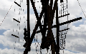  4 PM – 7 PM    Illumination on the Quad  8 PM – 10 PM  Carnahan Quad | 14  Movie: Migration  7 PM – 10 PM  Kuhlman Court  
15  Peter Miyamoto Faculty  Piano Recital  Whitmore Recital Hall  3 PM – 4 PM | 16 | 17  Mizzou Racing FSAE1000:  Low Voltage Electronics  Geology 123 (Keller  Auditorium)  5 PM – 6:30 PM | 18  Grill and Chill  Free BBQ dinner  Southwest Lawn  5 PM – 7 PM | 19  Summer Welcome Reunion  Ice Cream and Yard Games    4:30 PM – 6:00 PM  Carnahan Quad | 20 | 21  Heritage Festival  Nifong Park  10 AM – 5 PM
22  Heritage Festival  Nifong Park  10 AM – 5 PM | 23 | 24  Downtown Scavenger Hunt  Lowry Hall  4 PM – 6 PM | 25 | 26 | 27  Professional Developmenent    for Instructors  MIDTESOL  Council Bluffs, IA  [No IEP Classes] | 28
29 | 30  Wind Ensemble  Missouri Theatre  7 PM - 8 PM

 | October 2024
Sun | Mon | Tue | Wed | Thu | Fri | Sat
 |  | 1 | 2 | 3  Board Game Night  5:30 PM – 7:30 PM    MU Student Center Main Floor | 4  Movie: Corpse Bride  Kuhlman Court  7 PM – 10 PM   | 5
6 | 7 | 8  Culture & Cuisine:  Hispanic Heritage  Celebration  The Shack  6 PM – 8 PM | 9 | 10  IEP Midterm Exams  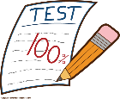 | 11  IEP Midterm Exams | 12
13 | 14   | 15 | 16  Homecoming Picnic  Kuhlman Court  1 PM – 3 PM | 17 | 18 | 19  Homecoming  
20 | 21 | 22 | 23 | 24  Spooktacular  MU Student Center  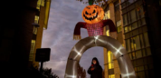  7 PM – 10 PM | 25 | 26
27 | 28 | 29 | 30 | 31 Halloween  

 | November 2024
Sun | Mon | Tue | Wed | Thu | Fri | Sat
 |  |  |  |  | 1 | 2  Intenational Welcome Party  MU Student Center    6 P M – 8 PM
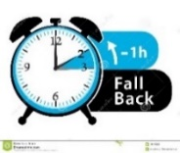  3 Daylight Saving Time  Ends | 4 | 5 Election Day   | 6  Caffeination Station  MU Student Center - Info  Booth  1 PM – 3 PM |   7  Board Game Night  MU Student Center –  Main Floor  5:30 PM – 7:30 PM | 8 | 9
10 | 11 | 12 | 13  Decorate a Tote Bag  The Shack  3 PM – 5 PM | 14 | 15 | 16
17 | 18 | 19  Tiger Tea Party  GOBCC  3 PM – 5 PM | 20 | 21 | 22 | 23
24 | 25 | 26 | 27 | 28 Thanksgiving Day!  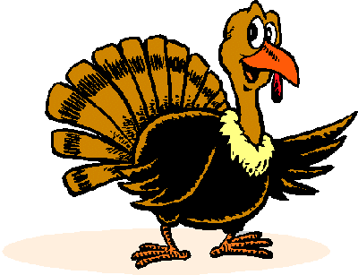  Thanksgiving Break [No Classes] | 29   | 30

 | December 2024
Sun | Mon | Tue | Wed | Thu | Fri | Sat
1 | 2 | 3  Brain Break  MU Student Center  1 PM – 4 PM | 4 | 5  IEP Final Exams  Winter Extravaganza  MU Student Center  6 PM – 8 PM   | 6  IEP Final Exams  Living Windows Festival  6 PM – 8 PM | 7
8 | 9  IEP Battery of Tests    Time: TBA  [Reminder: All students are  required to take the Battery of  Exams] |   10  Institutional TOEFL  Time: TBA  [Reminder: All students are  required to take the TOEFL ITP]  Potluck and Awards  12:00 noon after the exams | 11 | 12  IEP Final Advising | 13  Students who believe that they will be matriculating into a degree program at the university for Spring 2025 should not plan to leave Columbia until after 5:00 pm Friday, December 13 at the earliest. | 14
15 | 16 | 17 | 18 | 19 | 20 | 21
22 | 23 | 24 |   25  Christmas | 26 | 27 | 28
29 | 30 | 31  New Year’s Eve   | Notes: Wednesday, January 15, 2025, 9:00 am – 10:00 am - Registration for continuing in the IEP for the Spring 2025 semester.

